Term’s
1) Command Line Interface (CLI)
A Command Line Interface (CLI) is a text-based user interface used to interact with software and operating systems by typing commands. Unlike graphical user interfaces (GUIs), which rely on visual elements like buttons and menus, CLIs require users to input textual commands.
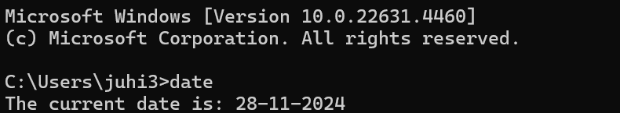
2) Graphical User Interface (GUI)
A Graphical User Interface (GUI) is a visual-based interface that allows users to interact with software and hardware through graphical elements such as windows, icons, buttons, and menus. Unlike a Command Line Interface (CLI), which relies on text-based commands, a GUI enables users to perform tasks by clicking, dragging, and typing in a more intuitive and user-friendly way.

3) Client (in business context)
This refers to an individual or organization that hires or purchases services from an IT company or professional. In this context, a client could be a business that contracts an IT firm for software development, network management, or other IT services.
4) Software Company:
A software company is an organisation — owned either by the state or private — established for profit whose primary products are various forms of software, software technology, distribution, and software product development. They make up the software industry.
5) WOW (Way of working)
In software development, "Way of Working" (WOW) refers to the principles, practices, and processes a team or organization adopts to achieve its goals efficiently. Here's a breakdown of key components in a WOW framework for software development.
6) Business Logic
Business Logic refers to the part of an application that encodes the real-world rules and processes of a business domain. It determines how data is created, displayed, stored, and changed, guiding the software to behave according to business requirements.
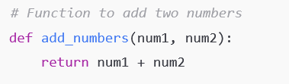
7) Presentation logic
Presentation Logic refers to the part of an application that manages how data is displayed to the user and how users interact with the system. It is the logic that decides what content the user will see, how the UI elements are arranged, and how the user’s input is handled before it interacts with the business logic or data layers.
8) DRY (Don't Repeat Yourself)
DRY is a fundamental software development principle aimed at reducing redundancy and improving maintainability. The idea is to avoid duplication of code, logic, or data, ensuring that every piece of knowledge or logic has a single, authoritative representation in the system.
The DRY principle promotes the idea that every piece of knowledge must have a single, unambiguous, authoritative representation within a system.
9) CMMI (Capability Maturity Model Integration)
CMMI is a globally recognized framework for improving processes and practices in organizations. It helps organizations improve performance, ensure quality, and align processes with business goals. Initially developed for software development, it now applies to various domains like service delivery, product development, and acquisition.
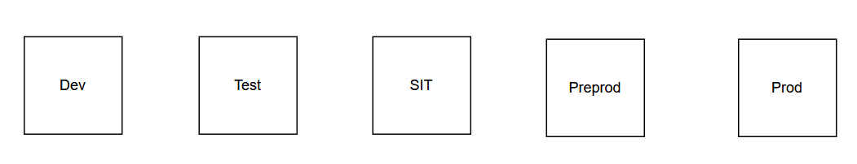
10) Build, Test, Release and Deploy
The Build, Test, Release, and Deploy phases are key stages in the Software Development Lifecycle (SDLC) and DevOps pipelines.

11) Deep drive into Build, Test, Release and Deploy
1. Build
- Definition: The process of converting source code into a binary or executable format that can run on a target system.
- Activities:
  - Compiling source code.
  - Linking libraries.
  - Packaging resources.
- Tools:
  - Build tools like Maven, Gradle, or Make.
  - Continuous Integration (CI) systems like Jenkins or GitHub Actions.
2. Test
- Definition: The process of validating that the software works as intended and meets requirements.
- Types of Testing:
  - Unit Testing: Testing individual components.
  - Integration Testing: Ensuring different components work together.
  - Functional Testing: Validating functionality against specifications.
  - Performance Testing: Checking system performance under load.
  - Acceptance Testing: Ensuring the system meets business requirements.
- Tools:
  - JUnit, Selenium, Postman for various types of testing.
  - CI tools to automate test execution.

Note: With the help of Build we are distributing the application into lower environment, but with the help of Deploy we are distributing the application in production environment.

3. Release
- Definition: The process of preparing a version of the software for distribution.
- Activities:
  - Versioning the software.
  - Tagging the release in version control.
  - Creating release notes.
- Tools:
  - Git for version control.
  - Release management tools like Jira, Azure DevOps.
4. Deploy
- Definition: The process of delivering the built and tested software to the environment where it will be used.
- Deployment Types:
  - Development Environment: For developers to test new changes.
  - Staging Environment: A replica of production for final testing.
  - Production Environment: Where the software is available to end users.
- Strategies:
  - Blue-Green Deployment: Minimizes downtime by running two environments.
  - Canary Deployment: Gradual release to a subset of users.
  - Rolling Deployment: Gradual replacement of old versions.
- Tools:
  - Docker, Kubernetes for containerized deployments.
  - CI/CD pipelines for automated deployments (e.g., Jenkins, GitLab CI/CD).

